KENILWORTH AND THE WARWICKSHIRE CUP
Since our first final in 77/78 there has always been some kind of misfortune lurking in the shadows for Kenilworth in the Warwickshire Cup. Indeed, ask any of the older generation at Kenilworth Rugby Club and the topic of conversation would inevitably have ended with the elusive Warwickshire Cup. We have been to many finals and over the years and never actually won it.
Well, all that was put to end at 8.40pm on Friday 15th May 2026 at The Butts Stadium, Coventry when our young team (average age of 24 and containing 13 ex colts), finally put the hoodoo to bed with a resounding 29-20 win over Broadstreet, a team who had previously defeated us in five of our previous nine finals. It did not quite match the exploits of our Intermediate Cup win in May 2019, but it came very, very close.
The ironic feature, I think, was the fact that many of our previous finals were contested by teams at their prime and containing many Kenilworth greats and legends and here was a young team, with 13 of the 18-man squad being ex colts, marshalled by a few old heads from our Twickenham triumph (Bobby Thompson, Gaz Renowden and Rhys Jones) winning the trophy.
We started the 2025/26 season with a new coach/DoR and a very young team. Early results did not go our way but the support sensed (from the Stratford win pre-Christmas) that things were changing and how right they were – winning seven of the last ten league games to finish comfortably in the middle of the league.
The first Warwickshire Cup (for junior clubs) appears to have been contested in the 1971/72 season with the first winners being Solihull. Solihull and Newbold then won the cup a further four and two times respectively before Coventry Welsh in the 78/79 and 79/80 seasons. Our first final was in 77/78 and, in total, Kenilworth, prior to this season, had reached nine finals. Broadstreet had previously defeated us in five of these finals.
1977/78: Newbold 9-15
We reached the final courtesy of wins over Old Laurentian, Stoke Old Boys, Barkers Butts and Pinley but lost to Newbold in the final at Coundon Rd – apparently conceding a very dubious try. Our history book says we were ravaged with injuries which meant promotion for a number of second team players and an injured Chris Wheatley playing on the wing. There is an iconic black and white picture of Chris. Features of this season were the formation of the Kenilworth Pirates and the fact that Taff Phillips retired having played 392 games. Notable players during this time were Rich Bennett, Bruce Doe, Steve Sutherland, Ian Jamie, Jim Turner and Dave Simmons.
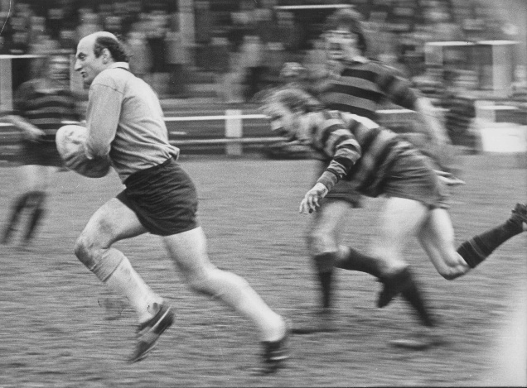

1990/91: Barkers Butts 6-24
The route to this final comprised of wins over Manor Park, Old Warwickians, Nuneaton Old Eds and Old Leamingtonians. The Old Leamingtonians semi-final at Stratford will live in the memory as Glyn Owen picked up a failed OL’s kick behind the post and ran it back so much so that we scored at the other end. This sent us to Coundon Rd to play Barkers Butts. Unfortunately, we were the ones who had to change strips and we ended up playing in the red Warwickshire strip. This turned out to be a fine excuse for miss passes and poor play and we ended up losing heavily, 6-24. Notable players in that team were Glyn Owen, Loz Sibley, Chris Sibley, Russel Brayshaw and Paul Fountaine.
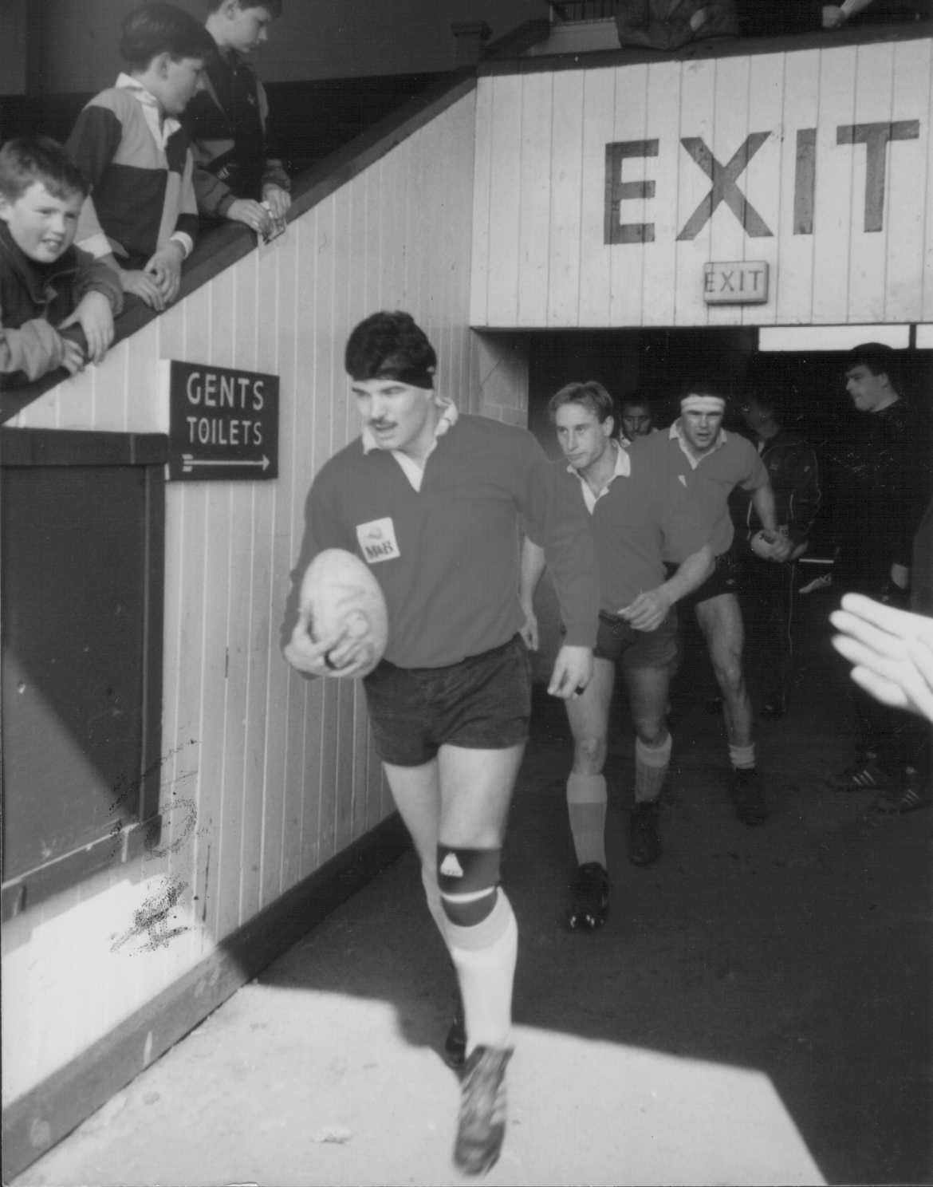

1994/95: Broadstreet 3-15
This was the first final of the Steve Brain era and the ‘superstars’ we had accumulated. Wins over GEC, Shipston and Newbold had taken us to the final at Nuneaton. Two of the ‘superstars’, prop Neil Riley and flanker Mark Ellis, had turned out for Warwickshire at Twickenham in the final of the County series the previous day. Both played the following day. There was also a shortage of scrum halves (due to injury) and Steve surprised us all by giving the nine shirt to Jeff Head. This still left us with a rather tasty back row of Mark Ellis, Nick Glasheen and James Fitzpatrick but the report says the ball did not get to our prolific backs and the game petered out in a 3-15 loss. Prominent players during this period were Paul Fountaine, Jason Minshull, Theo McCann, Jake Marvelly, Dom Carrick and Wayne Morgan. This was a season when we won 25 of our 30 games, losing only four and scoring in excess of 1000 points, gaining promotion as runners up to Luctonians.
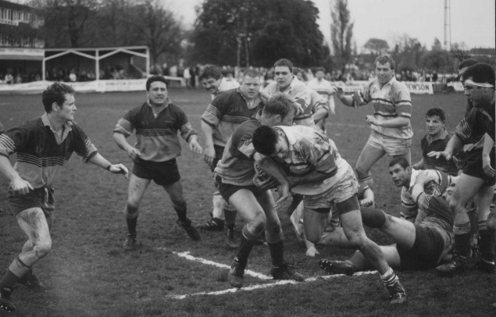

1997/98: Broadstreet 16-17
We reached the final at Coundon Rd courtesy of wins over Nuneaton Old Eds, Stratford and Newbold. We went behind with some loose play but the introduction of Theo McCann gave us some impetus with two late tries from Theo and Mark Bennett. We needed the conversion to win the game and into the very strong wind Mark took it on. It looked over from certain parts of the ground but alas not to the touch judges or referee and the game ended in a narrow defeat. Other notable players of this era were Neil Riley, Rob Varney, Chris Sibley, Jake Marvelly, Nick Glasheen, James Fitzpatrick and Charlie Westrope. 20 years on from the 77/78 final Bruce Doe also played in this one.

2005/06: Broadstreet 8-24
We had reached the final against Broadstreet (who, for once were at the same league level (6) as us) with a walkover over Copeswood and wins over Sutton Coldfield and Barkers Butts. What was it about Kenilworth and cup finals? Of all the ones that I can remember we have gone into the game with a reasonably settled team but on the day of the game it all goes pear shaped and we end up with big players not playing and guys out of position. It happened in this final, just like 94/95. Tak Norton had previously been injured once too often and decided not to play again that season. Fly half and ace kicker Lee Cassell got a dead leg in training on Thursday and thought he could shake it off but at 2.30 on Sunday it was decided he could not play. Tak Norton was persuaded into going onto the bench and Pete Roberts started at stand-off in a reshuffled back line with Ian Bowden coming in on the wing. It ended up in another cup final defeat. We were ahead early in the second half though when Reg Varney scored his normal cup tie try but the sin binning of second row Paul Whitehurst was critical and we then lost ground to eventually lose 24-8. The Kenilworth crowd were, as usual, big and very supportive and the bar was full on the Sunday night.
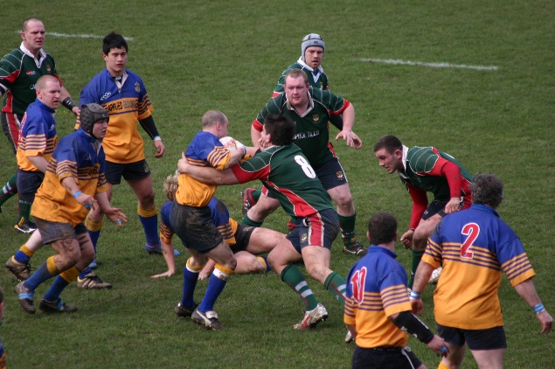

2006/2007: Broadstreet 7-22
This was the season that we won Mids 2 west handsomely to return to level 5 for the first time since 2003. We had defeated Silhillians and Newbold only to succumb to Broadstreet (a level 5 club), 7-22 for the second successive season at the new home of Coventry. Once again disruption to our team was the order of the day when centre James Hersey was forced to leave the field with a hamstring injury. We were not helped when the Broadstreet flanker was moved to unleash a series of haymakers and the referee Bruce Robinson, with experience at Premiership level, failed to sin–bin or red card him - apparently due to the fact that neither he nor his assistants could muster a red or yellow card between them?! Major players during this period were Mike Umaga, Andy Whitehall, James Burnside, Nick Smith, Mark Powell, Ian Phillips, Pete Roberts, Nick Collett, Gaz Renowden, Lee Cassell, Phil Jones, Luke Brown, Jez Noon, Glen Eager – all big players.

20014/15: Nuneaton
We had reached the final courtesy of defeating Old Coventrians in the first game of the season and we followed this up with a 34-19 win over Berkswell and Balsall in January. We had started well in the league (Mids 1 west) but then fell away badly from mid-November onwards and our league status was in doubt. Nuneaton were going well in level 5, one above us. A decision was taken not to play in the final and the following press release was issued:
“Kenilworth Rugby Club, looking forward to playing in the Warwickshire County Final this coming Sunday against Nuneaton, has sadly and very reluctantly had to withdraw. This is as a consequence of an injury crisis that leaves them without 3 of their 4 first choice front row, including the skipper and Head Coach Jonny Cresswell who is awaiting knee surgery, Nick Collett, rib cartilage and Ross Lowthian with damaged ankle ligaments. Whilst such injuries would not normally prevent the Glasshouse Lane club from fielding a squad for the final, having ‘survived the season’ with only a bare minimum of Front Row players, they now find ourselves in a situation whereby they simply have insufficient players who can safely fill the key front row positions particularly as Cup rules require 5 Front Row capable players to be available for the Final. Kenilworth’s situation is further compounded by the need to continue to compete in league games by ensuring the scrums remain ‘competitive’ – so if at any time they are unable to field 4 Front Row for the remaining league games they are at risk of accruing penalty points – thus putting the side at risk of unexpected relegation. A request to delay the final until the end of the season was denied by Warwickshire RFU. “
For this we were banned from entering the cup for the next few seasons.
Some players missing out this year were Josh Hickman, Rhys Jones, Ed Hannam, Johnny Cresswell, James Wadey, Joe Jepps, Mikel Andresen, Tom Lane, Ross Lowthian, Nick Collett and Matt Gibson.

2021/22: Nuneaton 26-27
In Nov 21 we played the higher ranked Nuneaton and lost 26-27 at (rather strangely) Old Laurentian in November – we had a final conversion to win the cup but it was not to be. At the time it was probably the closest we had ever come. We had played one game to reach the final, a pre-season game at Newbold which saw the emergence of Mickey Ryan, and many others. We were going well in the league with a number of youngsters – Sam Peppitt, Ollie Stone, Ben Harrison, David O-Fordjour marshalled by Bobby Thompson, Mikel Andresen and Jake Dodd. Mistimed aerial challenges led to yellow cards for Garrett Bell and David Opoku-Fordjour in the opening 15 minutes. Whilst Nuneaton also fell foul of the referee in the opening stages, the enforced changes and reorganisation restricted Kenilworth's chances of capitalising on the early dominance imposed by their pack. Kenilworth then lost young scrum half Will Canning to concussion after a late swinging arm to the head only yielded a yellow card to the Nuneaton flanker. All seemed lost as we entered the closing stages of the game 19-27 down. We were then awarded a penalty try and the referee announced there was still a minute to play. From the resultant kick off Nuneaton infringed and presented us with a kickable penalty to win the game. Tyler Price stepped up to try and seal the victory but agonisingly seemed to lose his footing and the kick fell a couple of feet short.

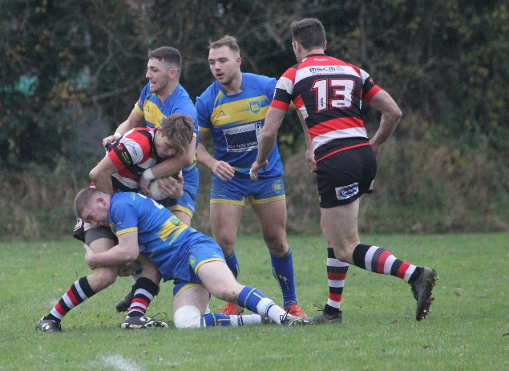

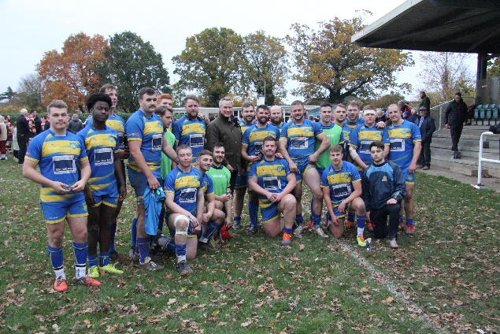

2022/23: Broadstreet 25-27

One year later it was a bit of a farce and we found ourselves in the final without either team playing a game. It was agreed that the league game at Glasshouse Lane in October (2022) against Broadstreet would double as the Warwickshire Cup final. We were always behind but with a few minutes remaining we scored a lovely try through Sam Peppitt, converted by Tyler Price, to take the lead 25-22 going into injury time and we were getting very excited. However, the referee conjured up an incredible amount of injury time which concluded with the inevitable Broadstreet try and victory to them 25-27. It was quite ironic that in the return league game at the end of January we ran out easy winners 37-22. This was Phil Boulton’s debut season for Kenilworth. I prophesised that one day it will happen and what a party there will be – maybe even matching our Twickenham win!
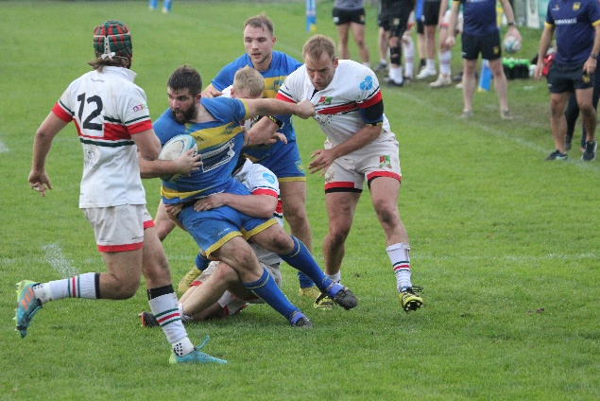

2025/26: Broadstreet 29-20 VICTORY AT LAST!
We were drawn to play Old Coventrians in the first round but they pulled out. Our semi-final at Sutton Coldfield was, arguably, a big turning point for the season, as we ran out 33-24 winners in a tight game - our try scorers being Ted Bromwich, Bobby Thompson, Joe Wilson, Finn Barnacle and Finn Nicholas. Broadstreet had got to the final without playing a game. They had also reached the promotion play offs which resulted in them playing games from mid-April to mid-May. Our last league game had been our stupendous win away at Luctonians on the 11th April to secure our league status. We were told that the cup final would be played pre 26/27 season but both Kenilworth and Broadstreet approached the Warwickshire RFU and suggested a date after Broadstreet’s play offs (which they won gaining promotion to level 5). Friday 15th May was agreed at The Butts.
Our team was: Bromwich, Morris, M Gibson: Howarth, Stockbridge: England, Fox, Thompson: Nichol, Barnacle, Herniman, Dhaliwal, Peppitt, T Hunter, O’Connor: Subs Hall, Bagnall, Davenport, Renowden, Jones, S Fountaine, D Hunter
The events are best described in RB’s splendid report:
The Warwickshire Senior Men’s Cup Final at the Nick Newbold Stadium in Coventry did not disappoint. The large crowd with a lot of dedicated Kenilworth travelling supporters were treated to some clinical, gritty and spirited rugby from their team. Broadstreet also played their part in an epic encounter.
Again, Kenilworth fielded a young side under skipper Ted Bromwich, with a creditable thirteen former mini and juniors in the squad. Furthermore, also including three players from the Twickenham Cup Final of 2019, Gaz Renowden, Rhys Jones and Bobby Thompson. Bobby playing his last ever 1st XV game before hanging up his boots. The whole squad showed they have come a long way in their ongoing development since the start of the season.
The match itself was played in lovely sunny May weather with Kenilworth playing with the slight prevailing wind in the first half. Immediately, from the kick off, Kenilworth were under pressure and they tenaciously defended in their 22-metre area with effective chop tackles. This iron-curtain defence was epitomized by an excellent try saving hold up from winger Sam Herniman. The opening try came from Kenilworth after 9 minutes, initial breaks by outside-centre Sam Peppitt and Ted Bromwich, finished off inevitably by Bobby Thompson whose instinct took him to the try line, to make the score 5-0.
This opening Kenilworth score was quickly followed by another try by full back Mark O’Connor after a lovely break by Joe England off a lineout. Mark O’Connor followed up his score with a beautifully struck conversion from wide out to extend the score to 12-0 after 14 minutes. Broadstreet were very quickly on the score sheet after they were given a kickable penalty in front of the Kenilworth posts from a scrum infringement. The penalty was slotted by full back Ambrose Deery, 12-3.
Kenilworth scored again on 26 minutes through fast ball of a ruck from 40 metres out; a lovely break by the jinking Sam Peppitt on an under’s line and a timed pass onto Finn Barnacle secured 5 more points from a very well taken try. This was converted by Mark O’Connor to take the score to 19-3.
The match was well refereed and policed by Warwickshire Society’s Jamie Hansen who penalized both teams where appropriate, the lineout and the scrum were well contested, with both sides trying to reach dominance in the set piece. From a scrum penalty and a kick into Broadstreet’s 22 metre area Kenilworth scored another try off a lineout drive from 12 metres out, which was scored, inevitably, by Bobby Thompson. This was again converted by Mark O’Connor to extend the lead to 26-3. Kenilworth’s ascendency at this point in the match was apparent.
Just before half time Kenilworth’s Finn Barnacle was shown a yellow card for a high tackle, this seemed to be an accumulative team offence, although to the knowledgeable spectators it seemed a bit harsh and a little out of context. Cest la vie.
After half time Kenilworth managed to score first through a well stuck penalty by Mark O’Connor to make the score 29-3. Broadstreet, however then found their collective mojo and started to make inroads into the match. They scored a well worked try from slick handling through their backs and right winger Jevon Zikala finished it off in the corner. This was unconverted. The impetus of the match was now with Broadstreet, to break this impetus Kenilworth brought on three replacements at once to give a lift to the team on the field of play and keep the defence as aggressive and tight as possible. However, from a Kenilworth infringement in their 22-metre area, Broadstreet scored again through direct running from their impressive number 8 Martin Wood, this was converted by Ambrose Deery to make the score 29-15.
Kenilworth continued to be determined and resilient in defence to suppress the Broadstreet direct running and wide attacks. The Kenilworth squad were able to go on the offensive at times in this period, but could not string together phases to create space.
Unfortunately, deep into the second half, replacement winger Rhys Jones was shown a yellow card for a high tackle, which again reduced them to fourteen men. This bizarrely seemed to be the catalyst for even more dogged defence from the Kenilworth squad who worked really hard together to quell attack after attack. Finally, within the last moments of the match, Broadstreet scored again through their full back Ambrose Deery after effective continuity and fast recycling of the ball. This was unconverted from wide out.
With the final whistle being blown, the amazing Kenilworth supporters were both relieved and ecstatic as this was the first time over forty years and eight finals, they have ever won the Warwickshire Senior Cup. The more senior members of the club remember the very close finals over the years and yet this time the rugby Gods were smiling down on the Kenilworth Club players and members. It was a hugely fitting end to the season and the pride shone through on this very memorable occasion. The support given to this men’s squad is always very much appreciated. Skipper Ted Bromwich triumphantly held the cup aloft and the ensuing celebrations went on through the course of the night. Full credit must go to the coaching team of Director of Rugby Matt Price, Jimmy Gopperth and Louis Hall who have done a sterling job of making this group more resilient and playing in the ‘Kenilworth way.’ Things bode well for the future in all of the aspects of Kenilworth Rugby.
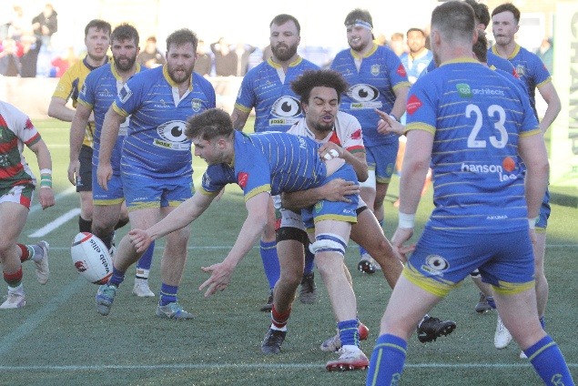

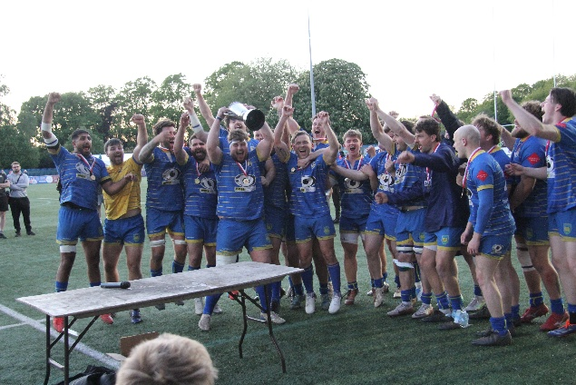
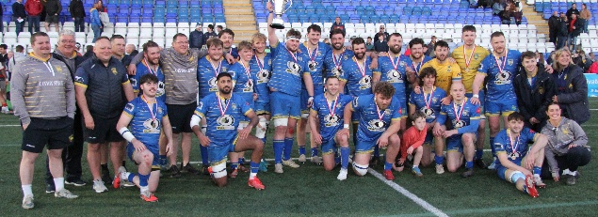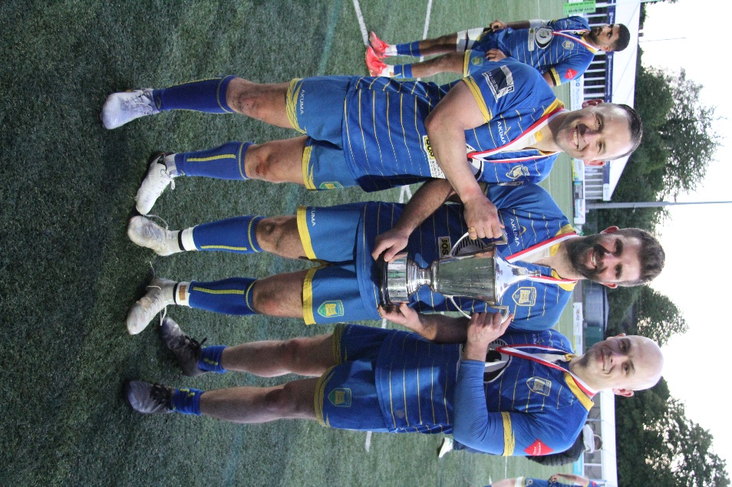

The full set of pics for the game and presentation can be seen HERE
The set of pics for the after-game celebrations can be seen HERE

Willie Whitesmith

